Intall JDK and tools on Windows

Install tools and jdk
[Windows] Terminal Setup 2
Part 1: Install Windows Terminal 2
Part 3: Install Git 2
Part 3: Install post-git 2
Part 4: Install PowerShellGet 3
Part 5: Install PSReadLine 4
Part 6: Install Scoop 4
Part 7: Install Oh-my-post 5
Part 8: Install Powerline-fonts 8
Part 9: Make command line in Windows Terminal to become beautifully 8
[Mobile + Web] web + android Setup (Real devices) 11
Part 1: Install JDK 11 11
Part 2: Install Maven 15
Part 4: Install IntelliJ Community 20
Part 5: Install Nodejs 20
Part 6: Install Android Studio 20
Part 7: Install Appium 26
Part 8: Install Appium Desktop 26
Part 9: Install Appium Inspector 26

[Windows] Terminal Setup
This article shows you how to set up Window terminal

Part 1: Install Windows Terminal
Pls access Microsoft Store on Windows machine, then search Windows Terminal and get it to install.

Part 2: Install Git
Pls access the website https://git-scm.com/downloads to download Git for Windows. Then pls install it
Part 3: Install post-git
Open Windows Terminal
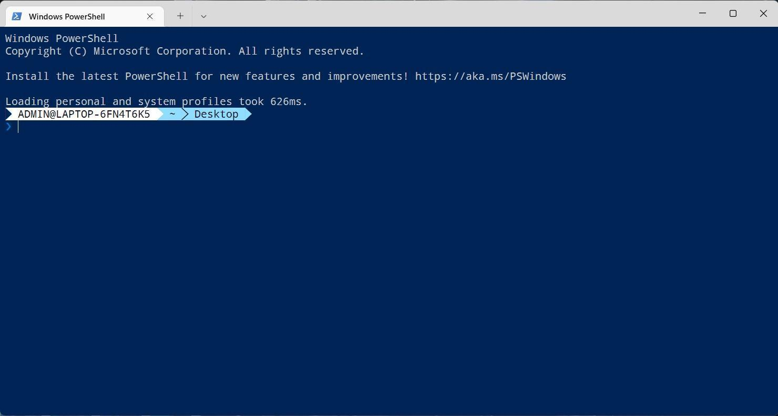

Install-Module posh-git -Scope CurrentUser
Paste the command in Windows Terminal, then press Enter
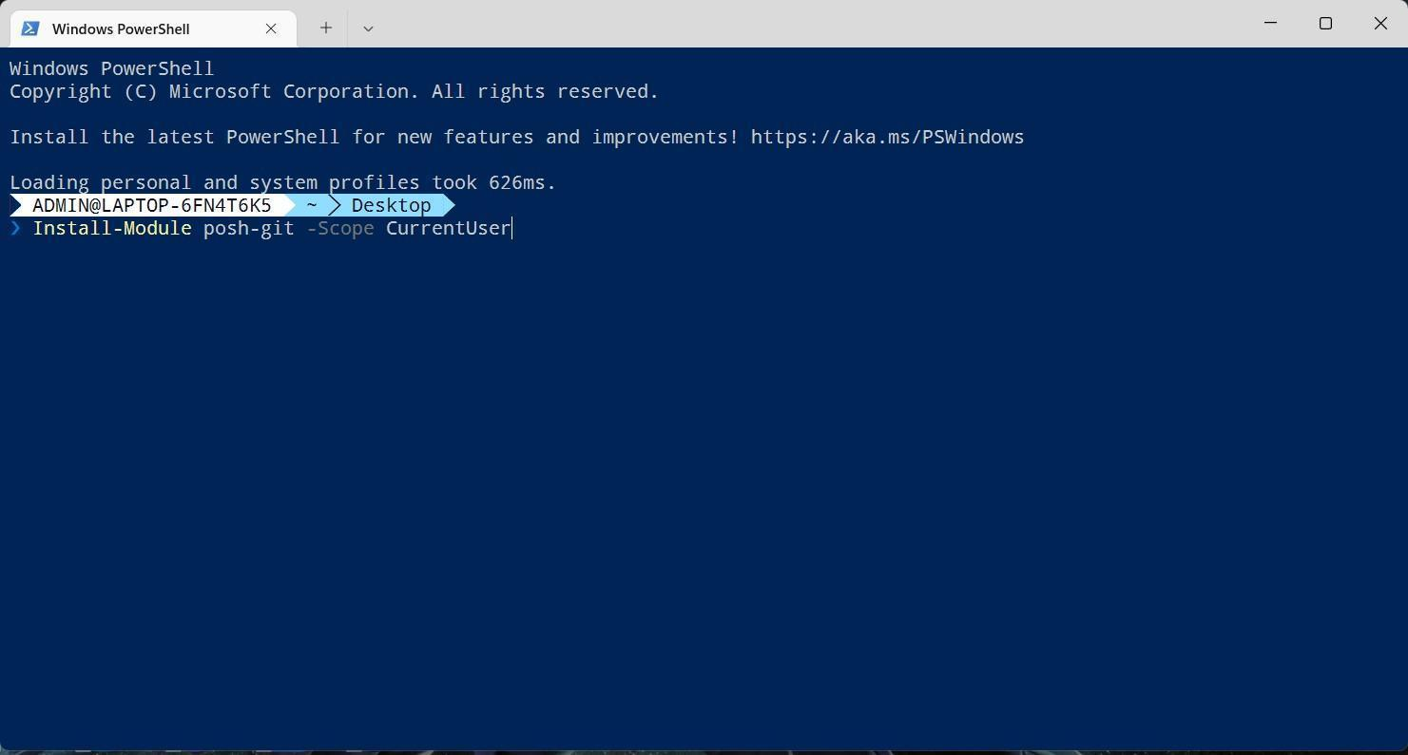
Part 4: Install PowerShellGet
Copy bellow command:
Install-Module -Name PowerShellGet -Scope CurrentUser -Force
Paste the command in Windows Terminal, then press Enter
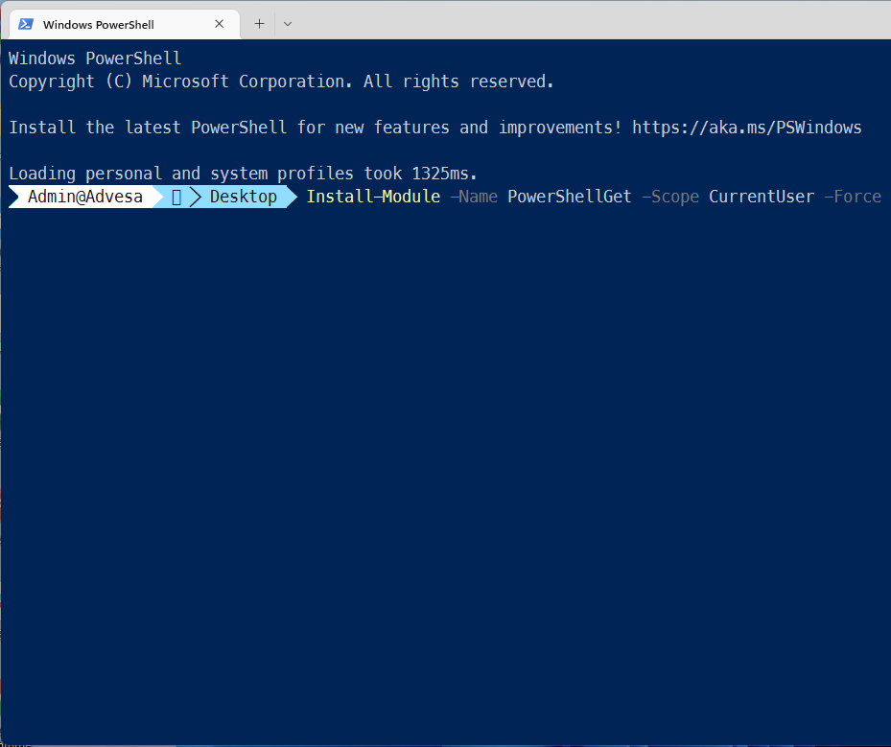
Part 5: Install PSReadLine
Copy bellow command:
Install-Module -Name PSReadLine -Scope CurrentUser -Force -SkipPublisherCheck
Paste the command in Windows Terminal, then press Enter
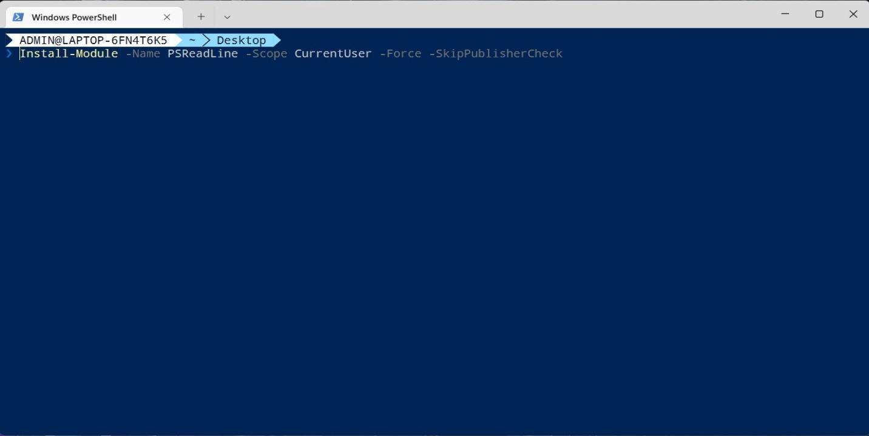
Part 6: Install Scoop
Copy bellow command:
Set-ExecutionPolicy RemoteSigned -Scope CurrentUser
Invoke-WebRequest get.scoop.sh | Invoke-Expression
Paste the command in Windows Terminal, then press Enter
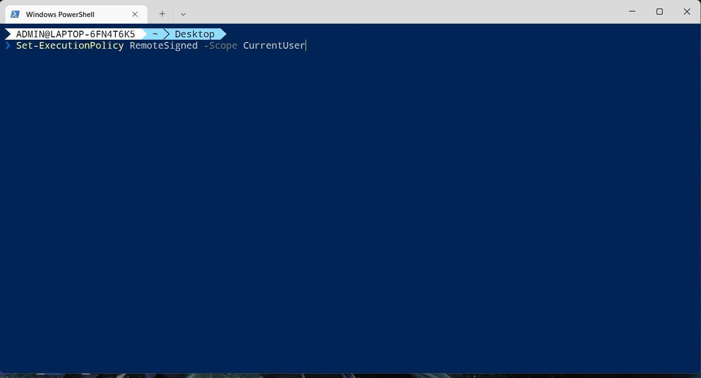
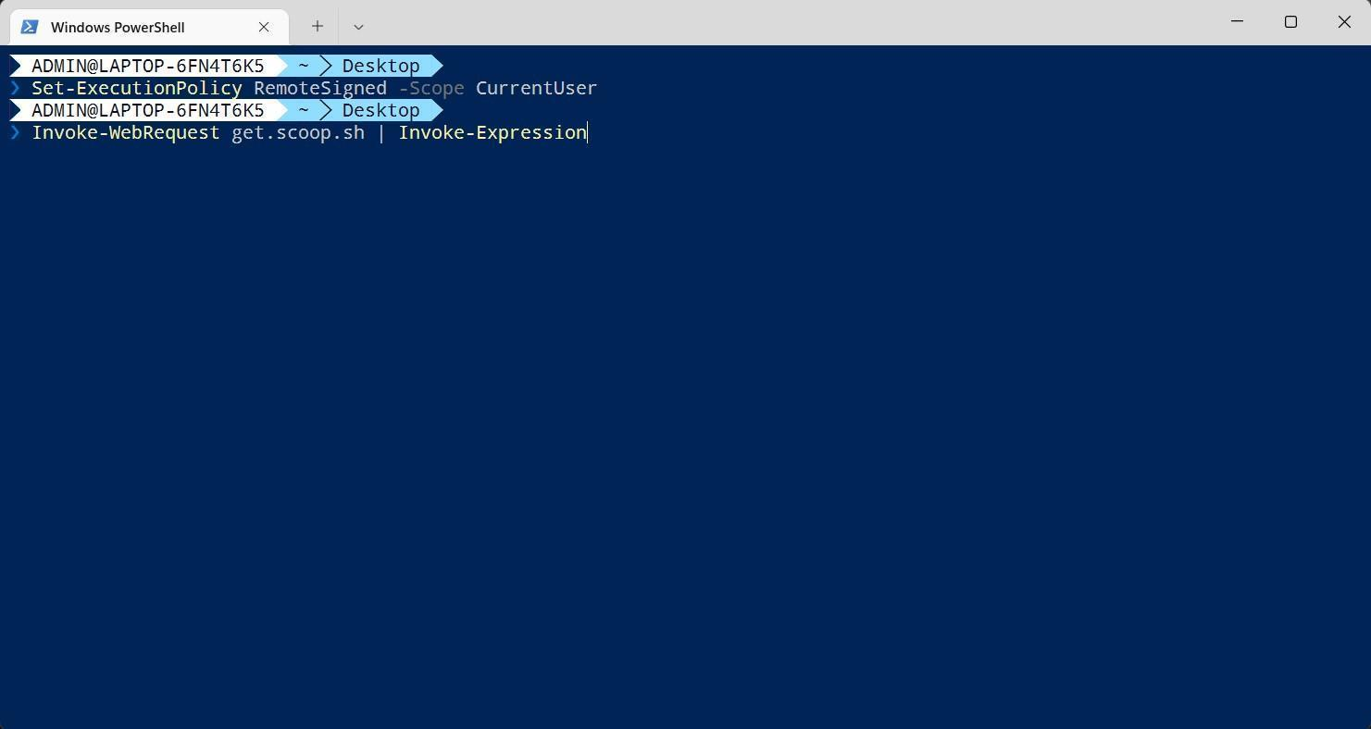

Part 7: Install Oh-my-post
Copy bellow command:
scoop install https://github.com/JanDeDobbeleer/oh-my-posh/releases/latest/download/oh-my-posh.json
Paste the command in Windows Terminal, then press Enter
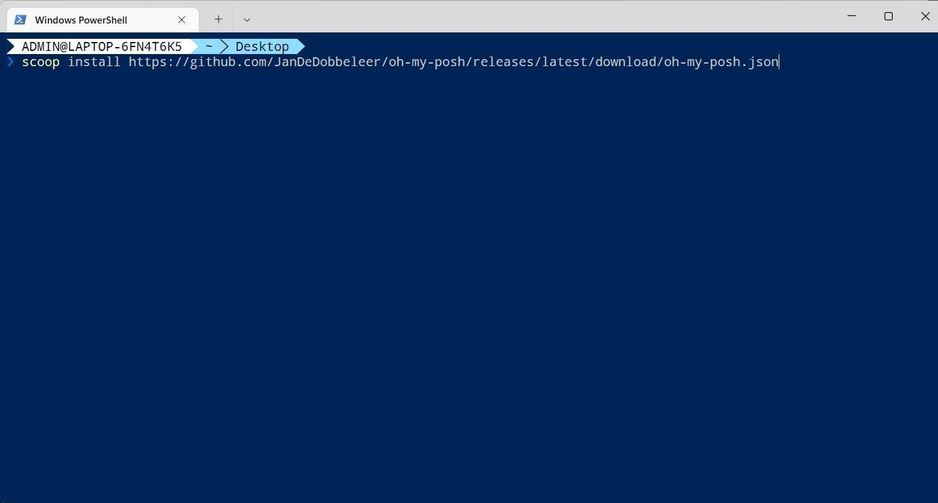
Open default Profile
notepad $PROFILE
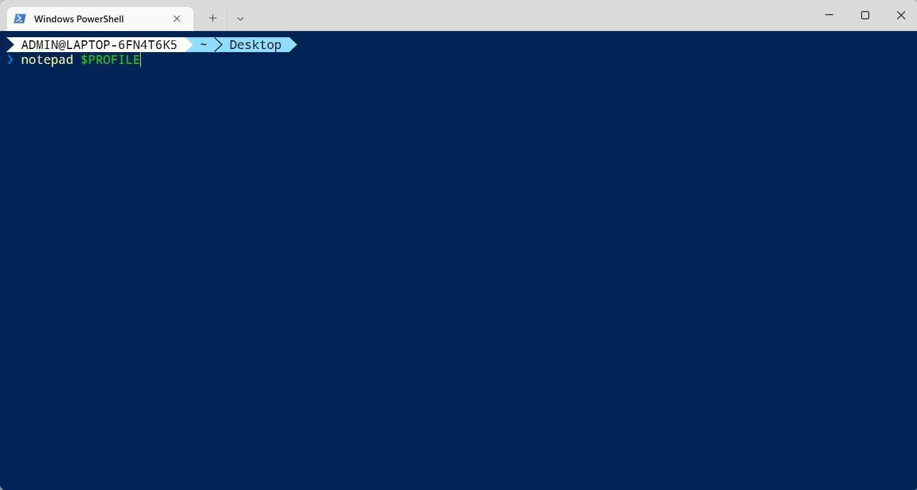
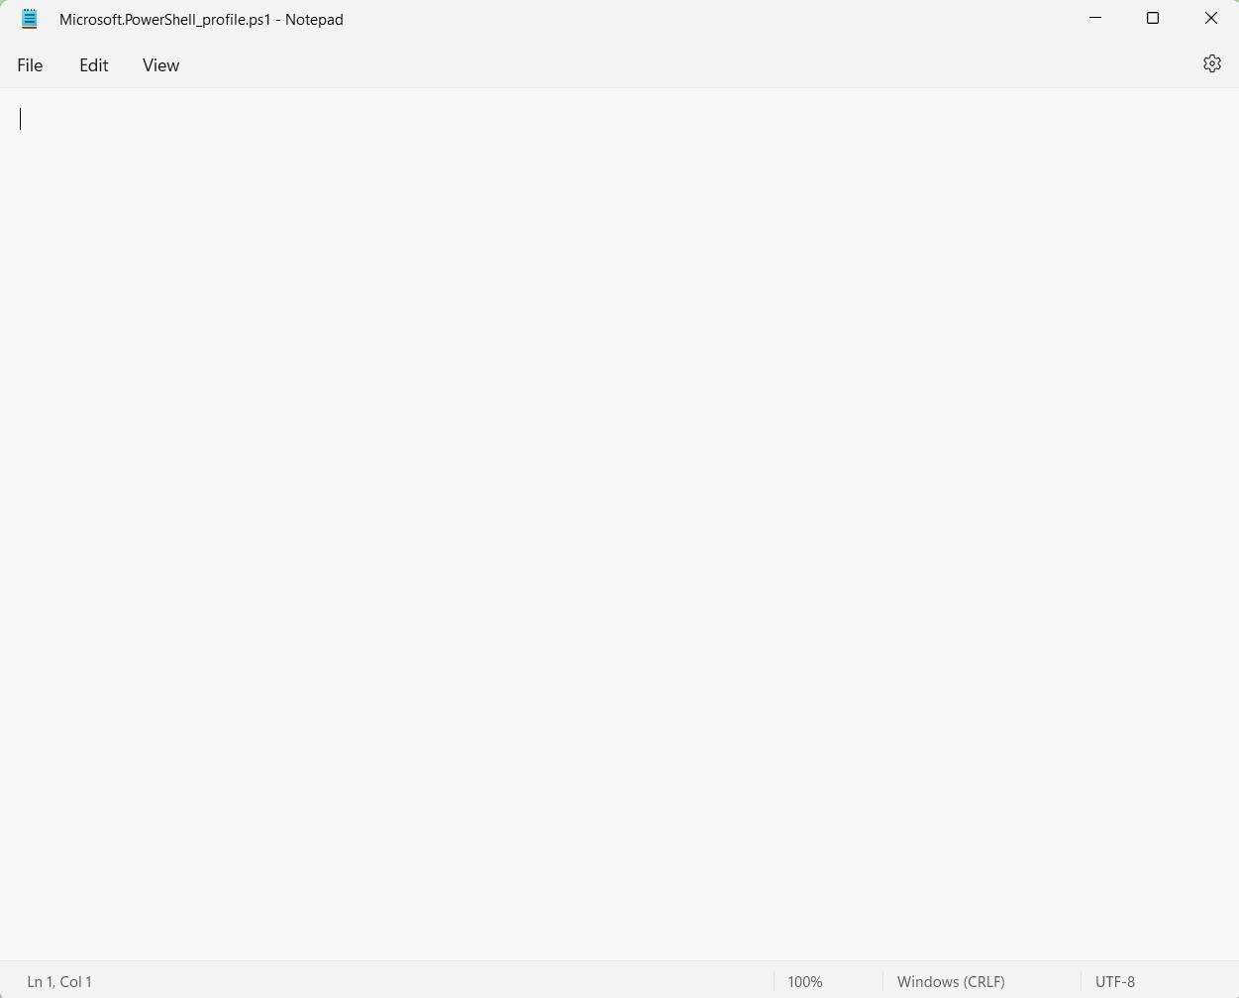
Copy/Paste commands below to notepad
Import-Module posh-git
oh-my-posh init pwsh --config 'https://raw.githubusercontent.com/JanDeDobbeleer/oh-my-posh/main/themes/agnoster.omp.json' | Invoke-Expression

Set-PSReadLineOption -PredictionSource History
# Shows navigable menu of all options when hitting Tab
Set-PSReadlineKeyHandler -Key Tab -Function MenuComplete

# Autocompletion for arrow keys
Set-PSReadlineKeyHandler -Key UpArrow -Function HistorySearchBackward
Set-PSReadlineKeyHandler -Key DownArrow -Function HistorySearchForward
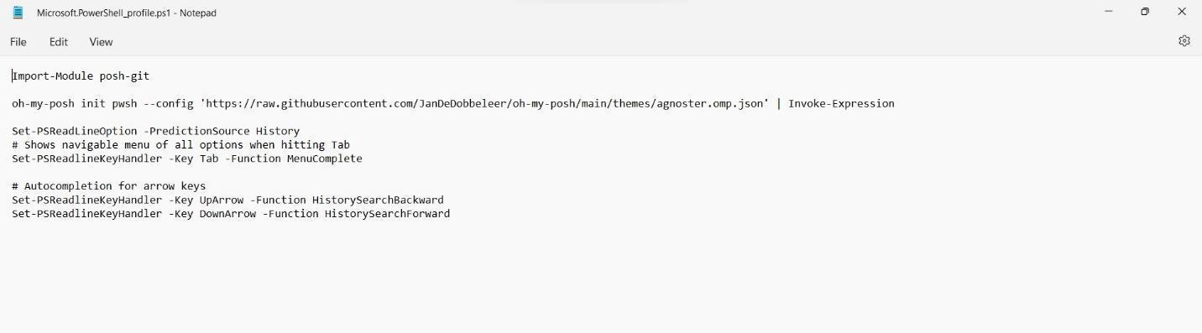
Part 8: Install Powerline-fonts
You can copy and paste these commands to your Windows Terminal
git clone https://github.com/powerline/fonts.git --depth=1
cd fonts
./install.ps1
cd ..
rm -rf fonts
Part 9: Make command line in Windows Terminal to become beautifully
Open Windows Terminal, then click down arrow and choose Settings
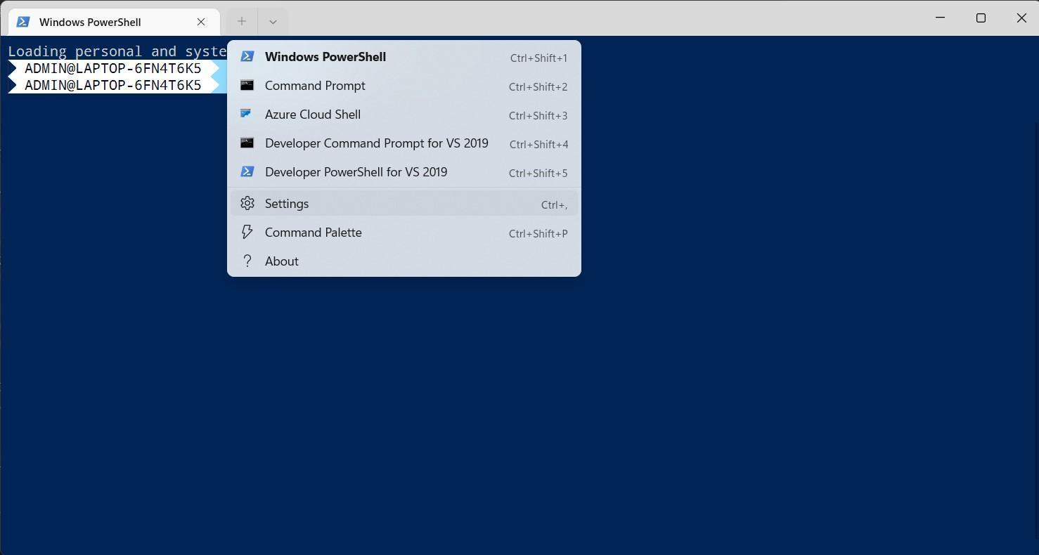
Choose Windows PowerShell
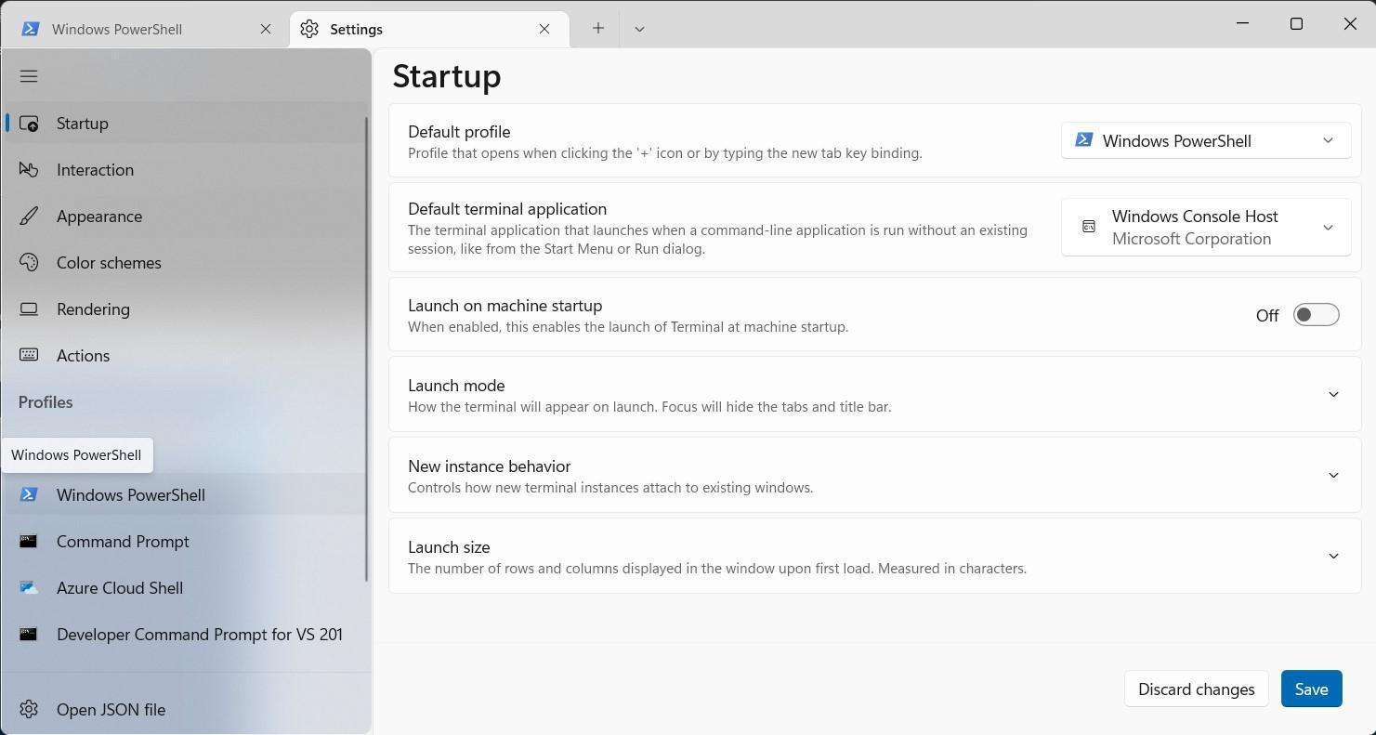 Scroll to Additional settings, then click Appearance
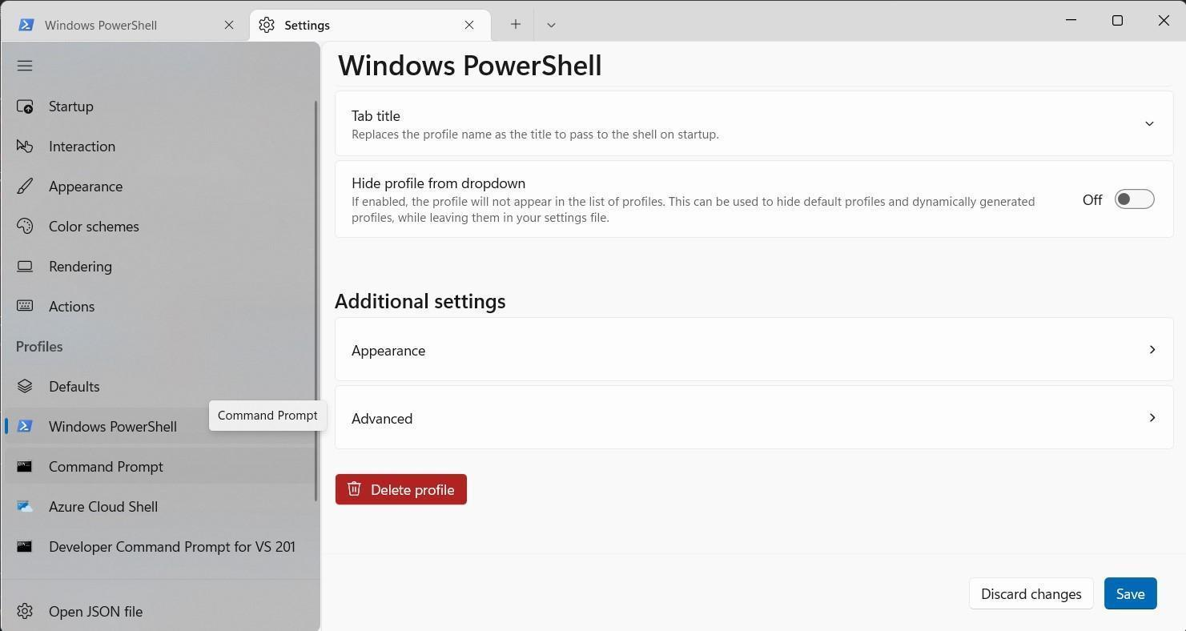
Choose font face (example: Noto Mono for Powerline) and font size (example: 12)
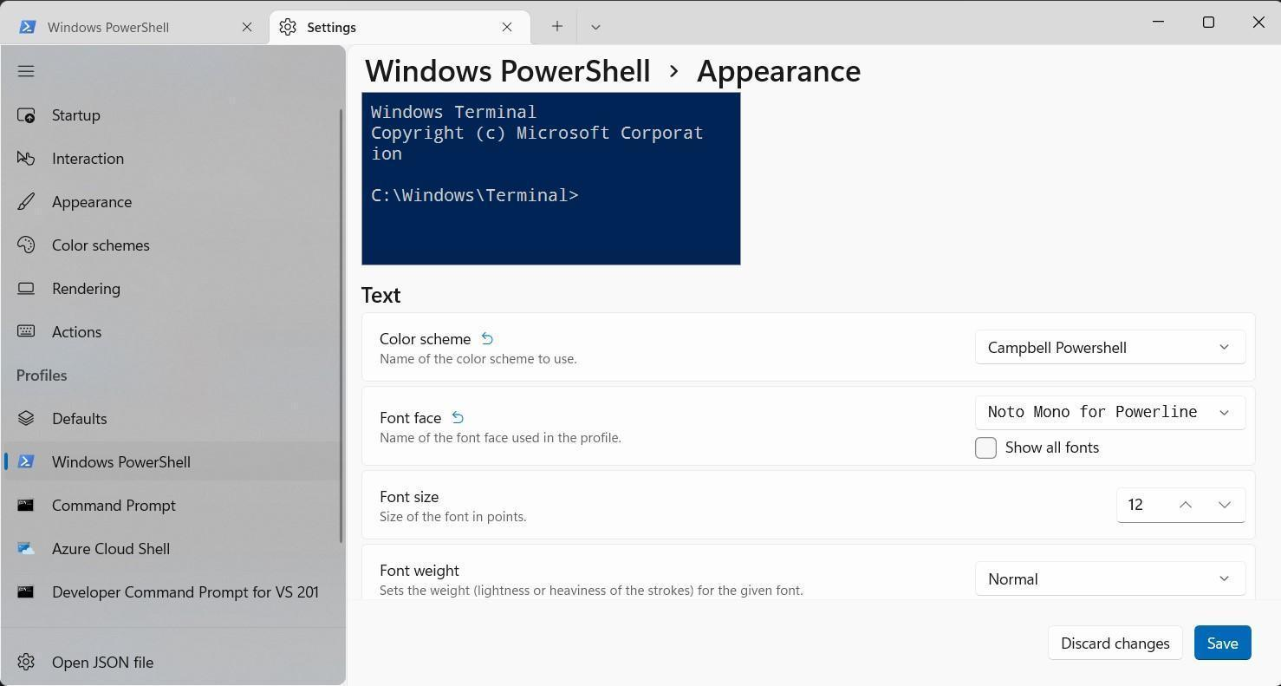
Click Save to save the settings

[Mobile + Web] web + android Setup (Real devices)
This article shows you how to set up real android devices, real web to Android application, and web application with automation framework using Selenium, Appium.
Part 1: Install JDK 11
Pls access the website https://www.oracle.com/java/technologies/javase/jdk11-archive-downloads.html to download JDK 11 for Windows.
After downloaded JDK 11, pls install it
Next, we will set JAVA_HOME environment variable on Windows
Click Windows icon bottom left corner, then search Edit the system
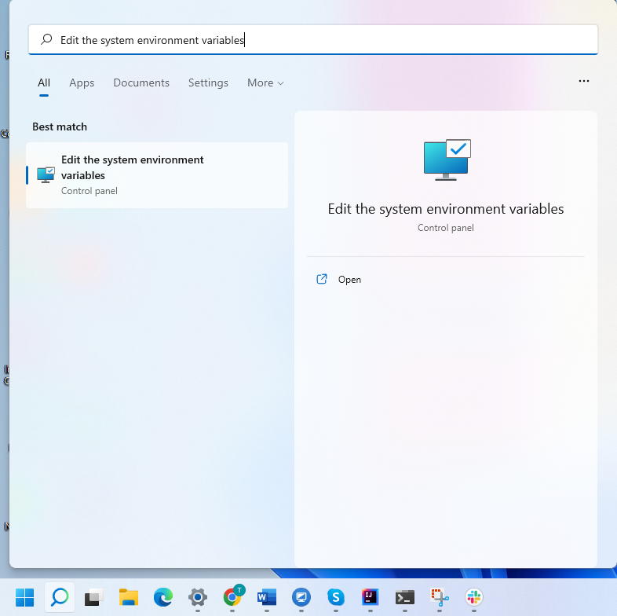
Choose Edit the system environment variables, appears System Properties window
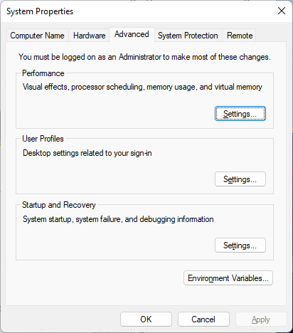
Click Enviroment Variables…


Click New at System variables
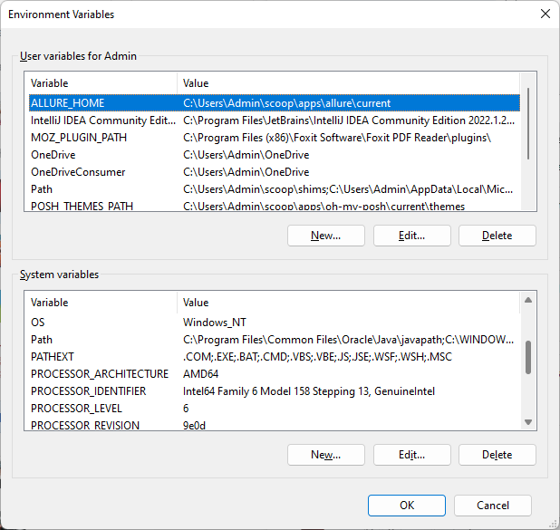

Input JAVA_HOME at Variable name textbox, input path of jdk (just install in C disk), example: my installed JDK path is C:\Program Files\Java\jdk-11.0.15
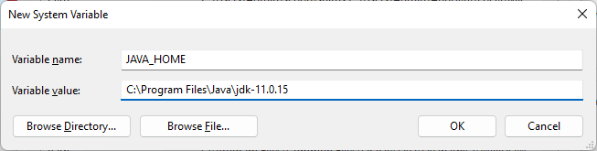
Click OK on New System Variable. Then find Path variable in System Variables table
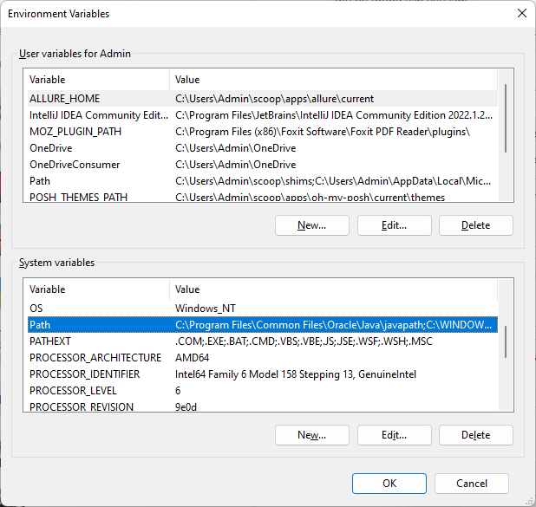
Double click to Path variable
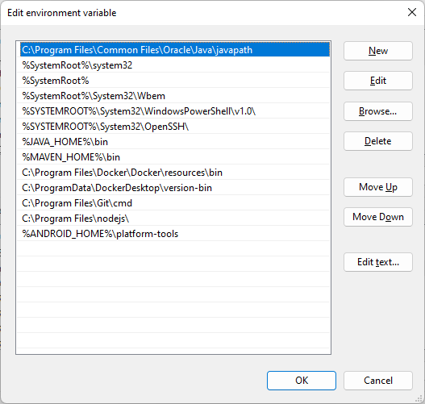
Click New on Edit environment variable, and input: %JAVA_HOME%\bin
Back to Windows Terminal and input: java –jversion
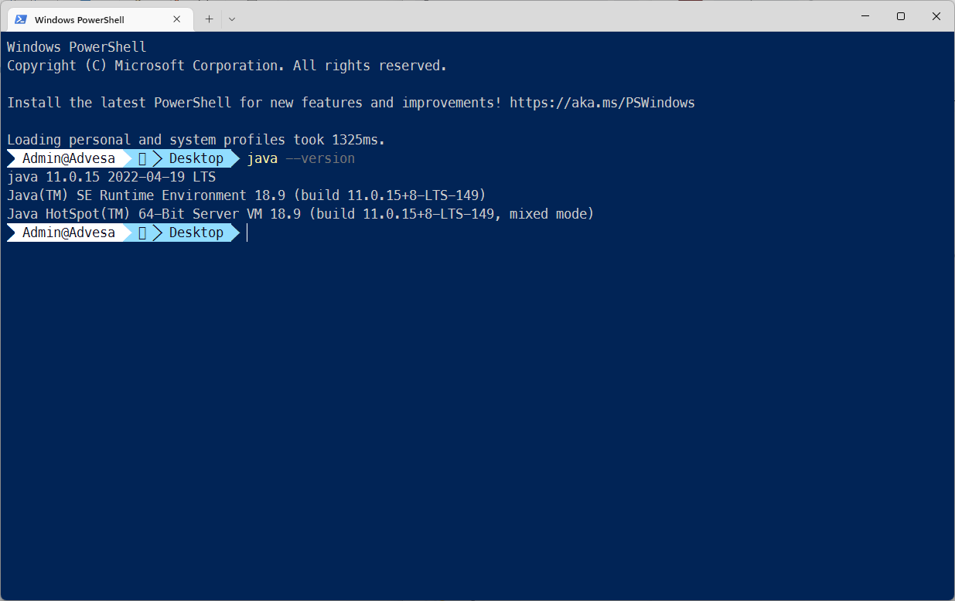
Part 2: Install Maven
Pls access the website https://maven.apache.org/download.cgi to download apache-maven-3.8.6-bin.zip.
Move apache-maven-3.8.6-bin.zip to a folder (Example: D:\maven)
Unzip the file in D:\maven
Next, we will set MAVEN_HOME environment variable on WindowsClick Windows icon bottom left corner, then search Edit the system

Choose Edit the system environment variables, appears System Properties window

Click Enviroment Variables…


Click New at System variables


Input MAVEN_HOME at Variable name textbox, input path of maven (just save it in D disk), example: my installed JDK path is D:\maven\apache-maven-3.8.6-bin
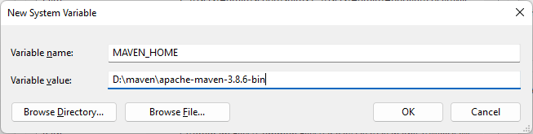
Click OK on New System Variable. Then find Path variable in System Variables table

Double click to Path variable

Click New on Edit environment variable, and input: %MAVEN_HOME%\bin
Back to Windows Terminal and input: mvn –version
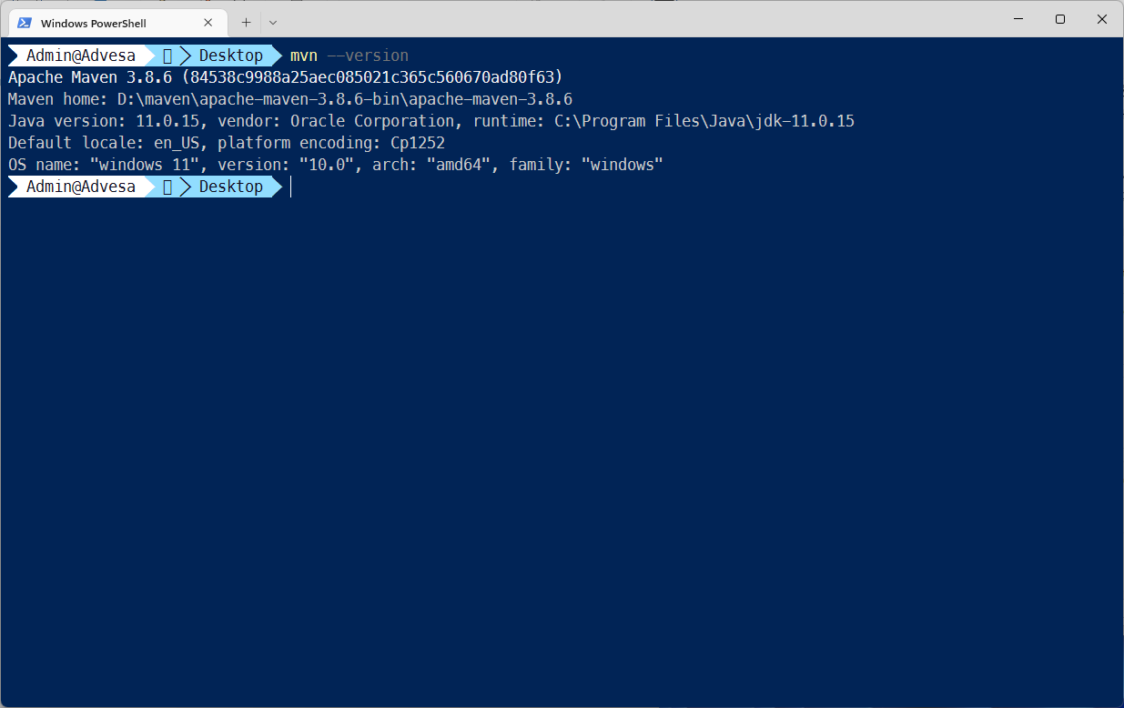
Part 4: Install IntelliJ Community
Pls access the website https://www.jetbrains.com/idea/download/#section=windows to download IntelliJ IDEA Community for MacOS, then install it.
Part 5: Install Nodejs
Pls access the website https://nodejs.org/en/download/ to download Nodejs for Windows, then install it
Part 6: Install Android Studio
Pls access the website https://developer.android.com/studio to download Android Studio for Windows, then install it
Next, we will set ANDROID_HOME environment variable on Windows.
First, we need to get path of SDK. Open Android Studio
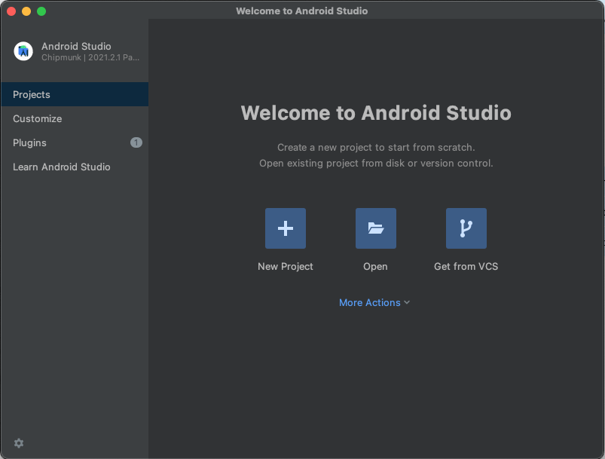
Click More Actions -> SDK Manager
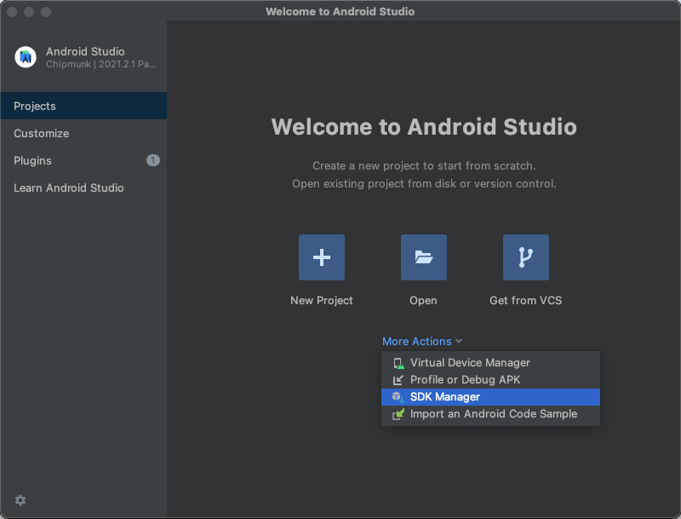
Copy path of SDK in Android SDK Location
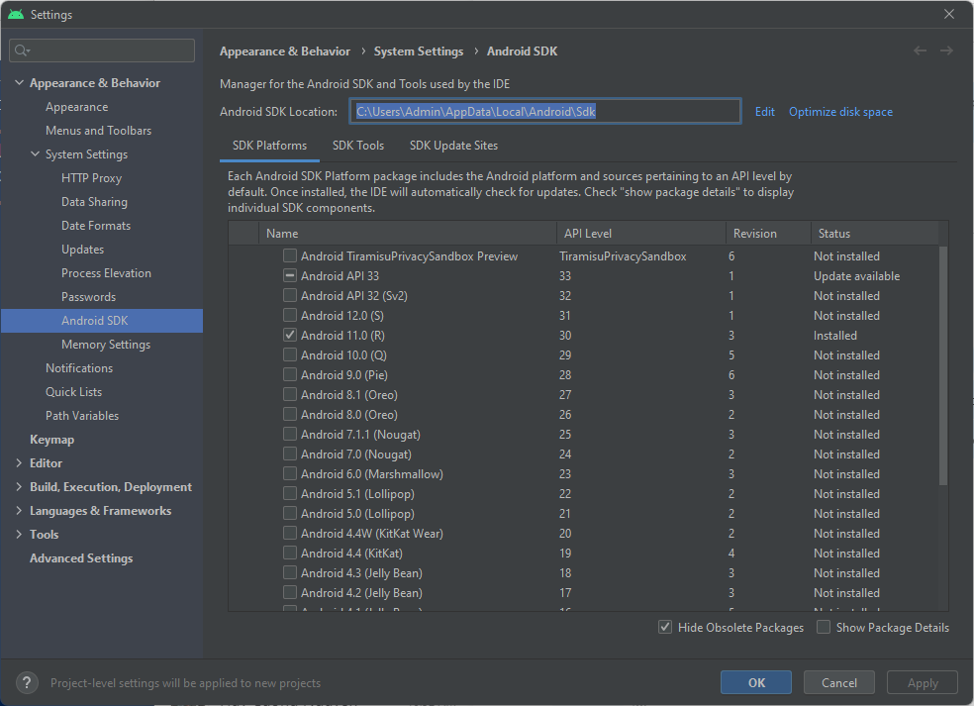
Click Windows icon bottom left corner, then search Edit the system

Choose Edit the system environment variables, appears System Properties window

Click Enviroment Variables…


Click New at System variables


Input ANDROID_HOME at Variable name textbox, input path of SDK, example: my installed SDK path is C:\Users\Admin\AppData\Local\Android\Sdk
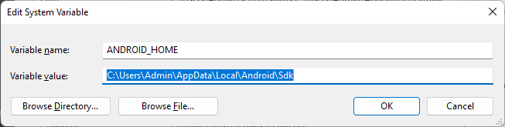
Click OK on New System Variable. Then find Path variable in System Variables table
Double click to Path variable

Click New on Edit environment variable, and input: %ANDROID_HOME%\platform-tools

Part 7: Install Appium
Open Windows Terminal, and input bellow command:
npm install -g appium
Input appium --version to check version of appium. If Windows Terminal show version of appium, you installed appium successfully.

Part 8: Install Appium Desktop
Pls access the website https://github.com/appium/appium-desktop/releases to download Appium Desktop for Windows, then install it

Part 9: Install Appium Inspector
Pls access the website https://github.com/appium/appium-inspector/releases to download Appium Inspector for Windows, then install it

